
Department of CSE

B.Tech. CSE Trimester -5

Roll Number-2520030587
Name- J.Sai Spoorthi

Cloud Infrastructure and Services
25CS2206E

PRACTICAL 2
2026

Experiment 1

Step 1: AWS Account Login and Security Setup
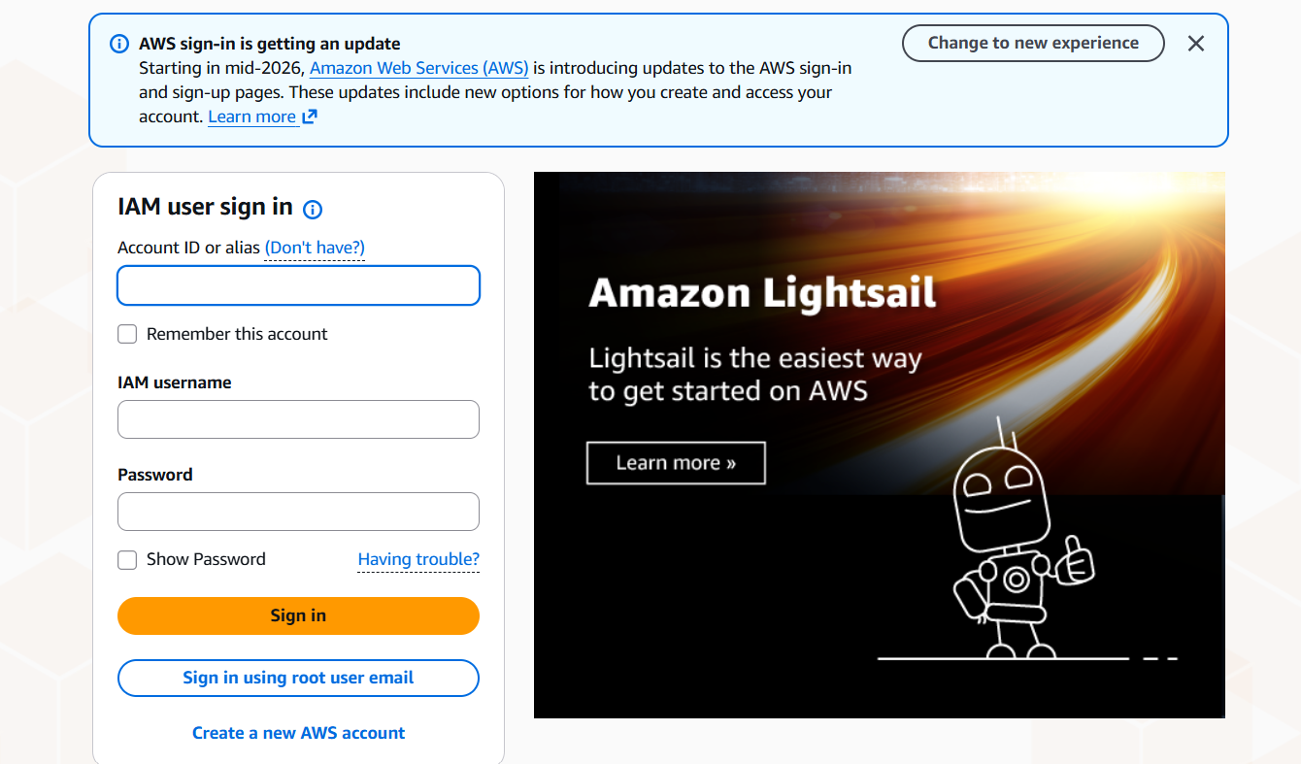
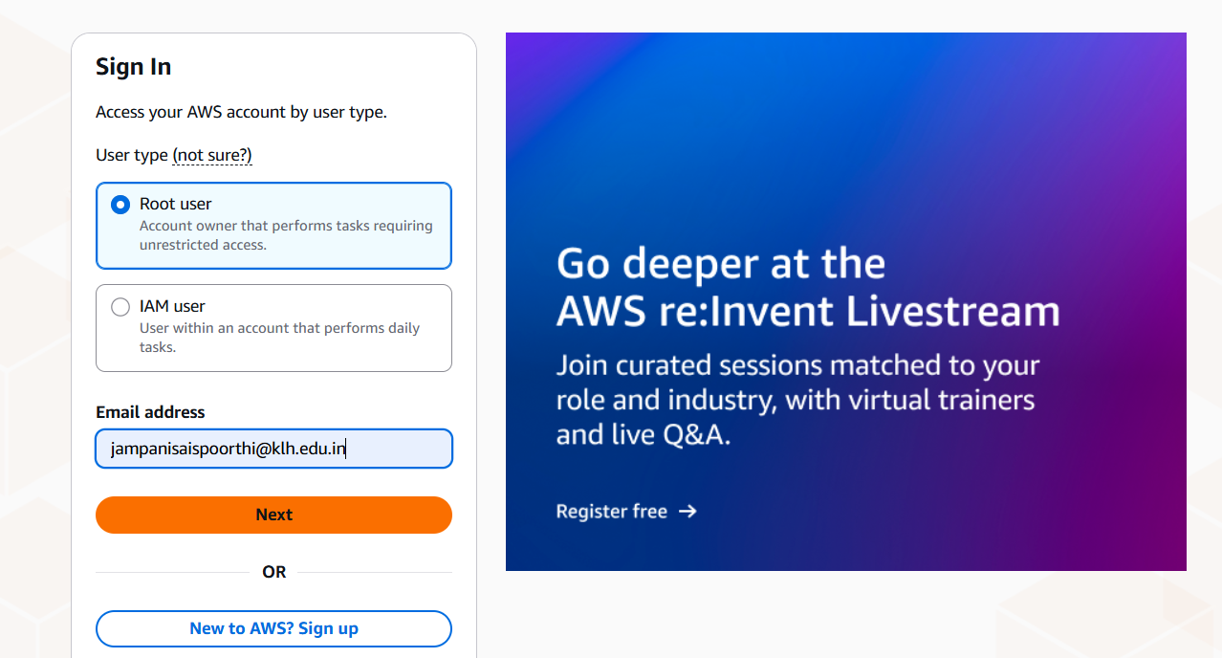

The AWS account sign-in process begins.

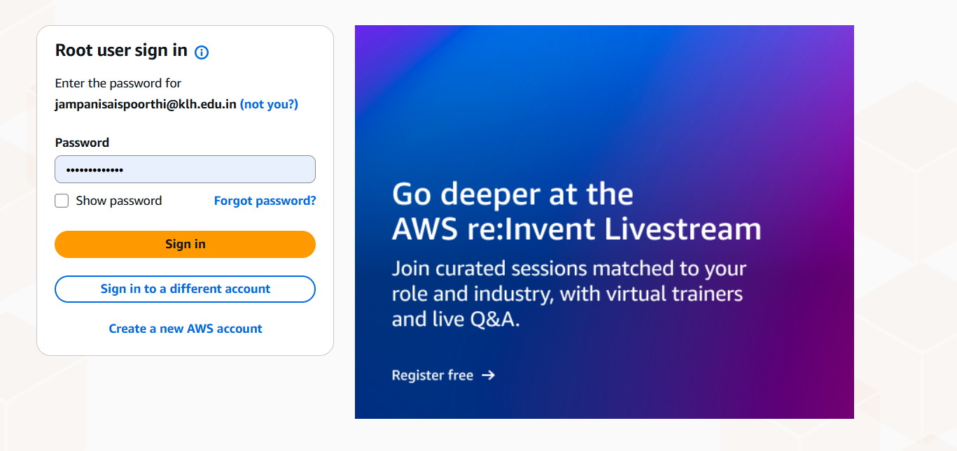

- Select the required authentication method.
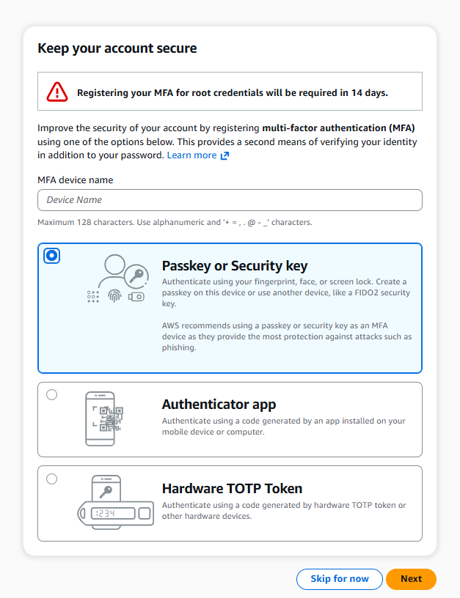the

1.Select the required authentication method.

Step 2 – Create a Security Key PIN
Description: A Google Password Manager popup appears to create a PIN for the security key.
Steps:
- Select the passkey/security key option.
- Enter a new PIN.
- Confirm the PIN.
- Click Continue.
Step 3– Security Key Registration Successful
Description: AWS displays a successful registration message after registering the security key.
Steps:
- Wait for registration to complete.
- Verify the success message.
- Check the registered security key details.
- Continue to the AWS account security page.

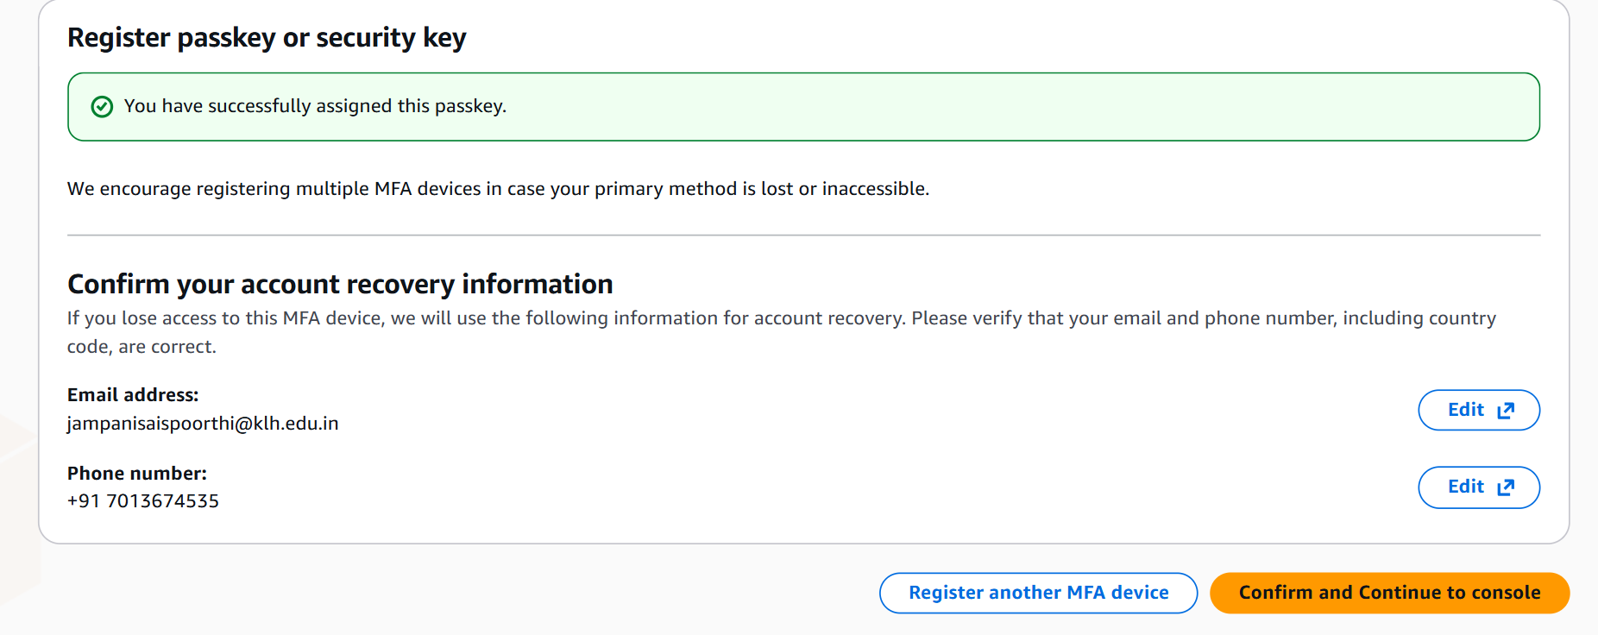

PART B – EC2

STEP 4:AWS Management Console Home
- After signing in, open the AWS Management Console.
- Observe the search bar at the top.
- Check the recently visited services.
- Locate the AWS services section.

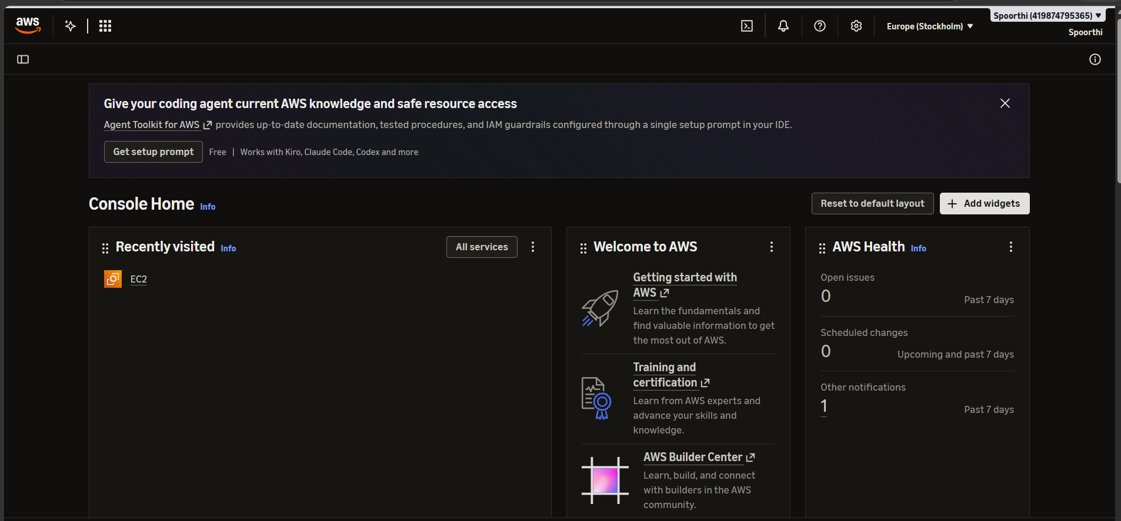
Step 5:Searching for EC2
Steps:
- Click the search bar at the top.
- Type EC2.
- Select EC2 – Virtual Servers in the Cloud.
- Wait for the EC2 dashboard to open.

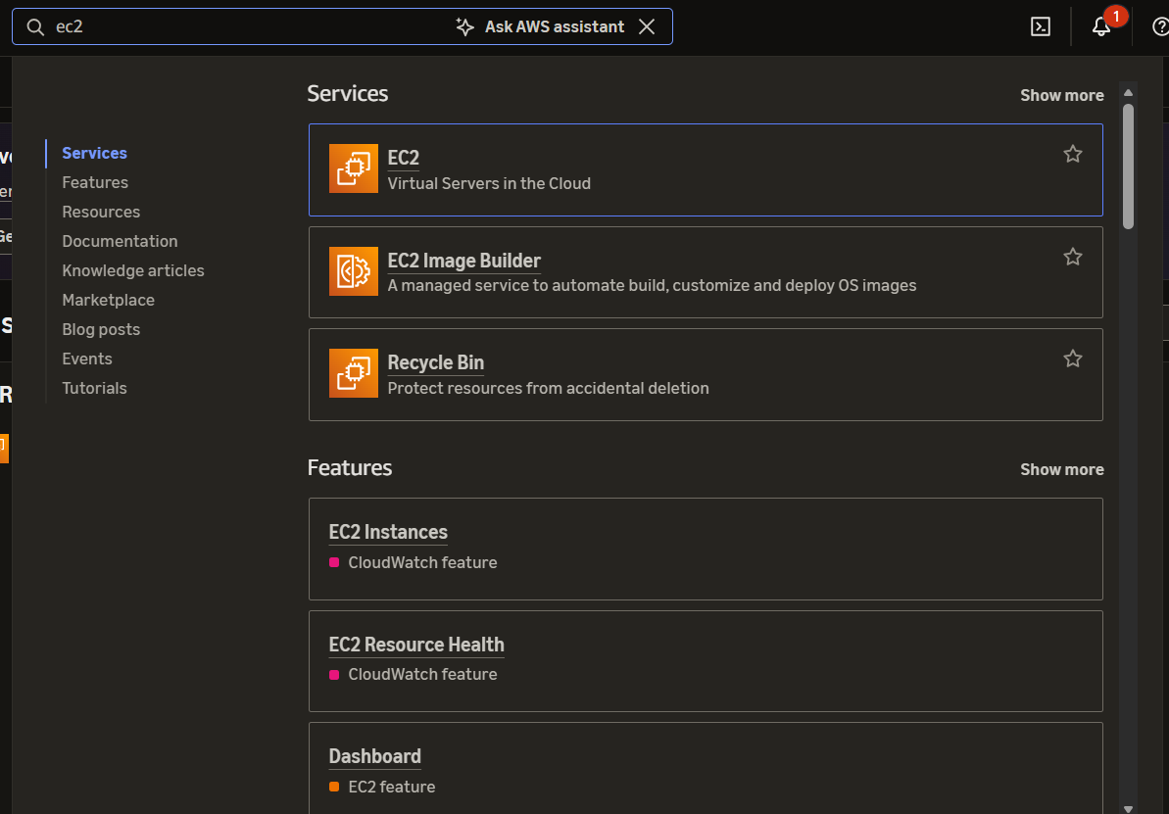
Step6:EC2 Dashboard
Steps:
- Open the EC2 dashboard.
- Check the Resources section.
- Observe the existing instance and key-pair counts.
- Click Launch instance.

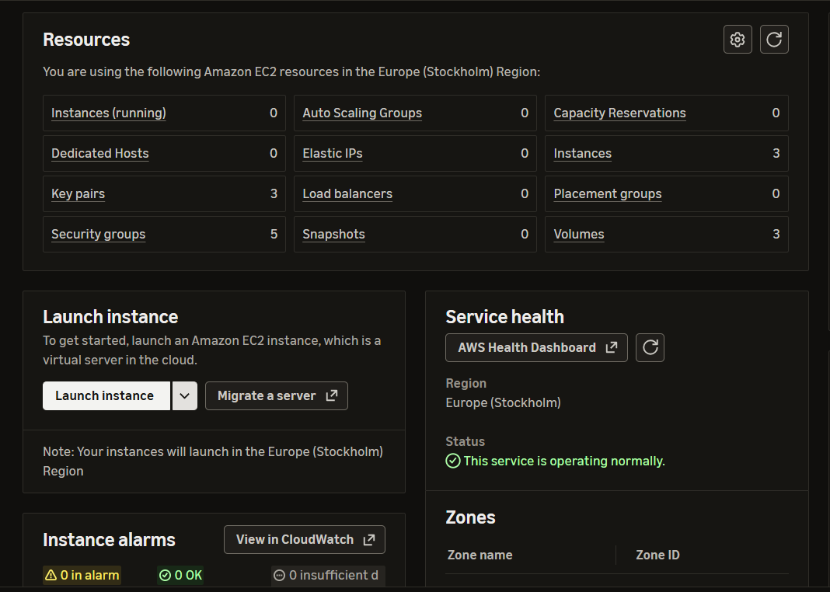
Step7: Launch an Instance
Steps:
- Click Launch instance.
- Enter a suitable name in the Name field.
- Open the Application and OS Images section.
- Select an operating system such as Amazon Linux or Ubuntu.
- Review the selected image

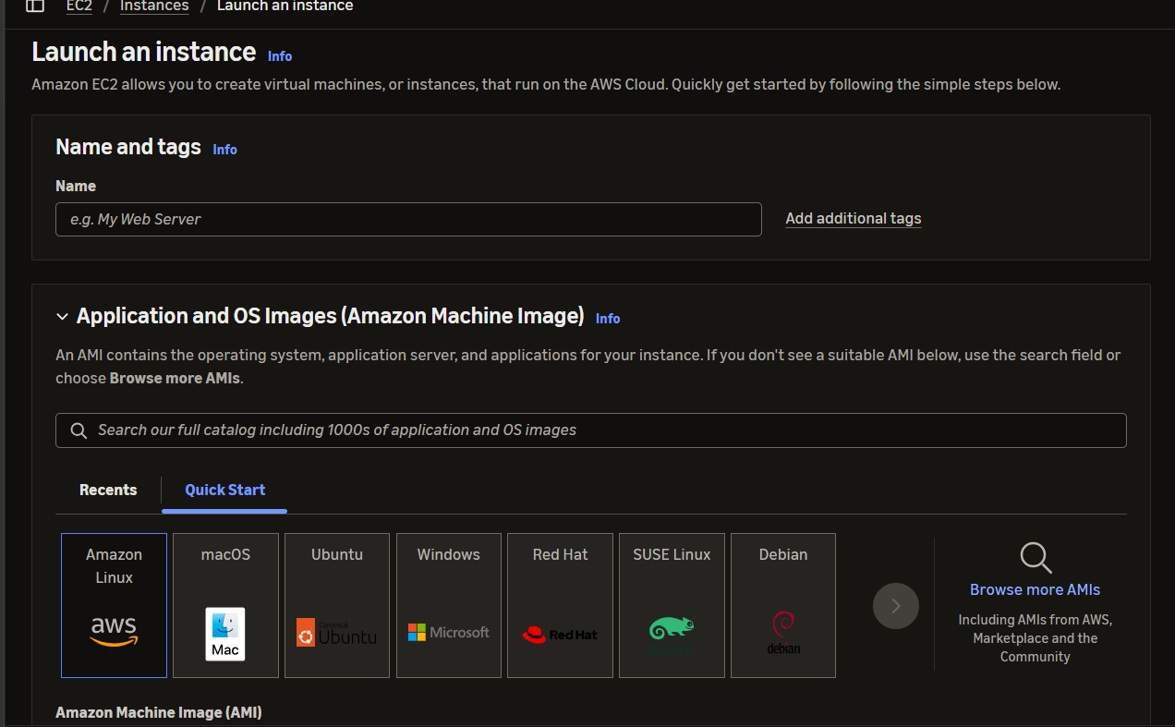
Step 8 :Selecting an Existing Key Pair
Steps:
- Scroll down to the Key pair (login) section.
- Open the key-pair dropdown.
- Check the available key pairs.
- If you do not have a suitable key pair, click Create new key pair.

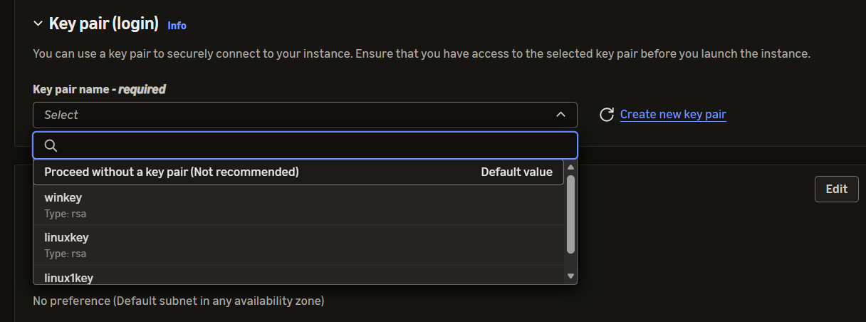

Step9 :Creating a New Key Pair
Steps:
- Click Create new key pair.
- Enter a suitable key-pair name.
- Select the RSA key type if following the configuration shown.
- Select the .pem private key format.
- Click Create key pair.
- Save the downloaded private key in a secure location.

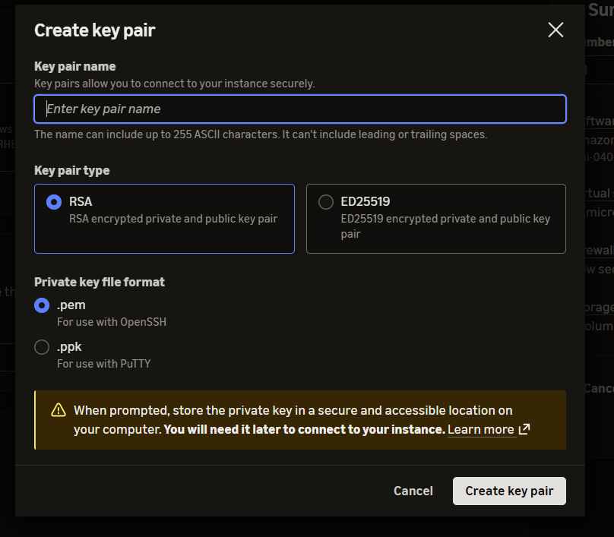
Step 10 :Downloaded Private Key
Steps:
- Open the downloaded key file location.
- Verify that the .pem file is present.
- Keep the file securely stored.
- Do not share its contents with others.

Step 11: EC2 Instances List
Steps:
- Open the EC2 dashboard.
- Click Instances from the left navigation panel.
- Find the newly created instance.
- Check its instance state.
- Wait until it shows Running.

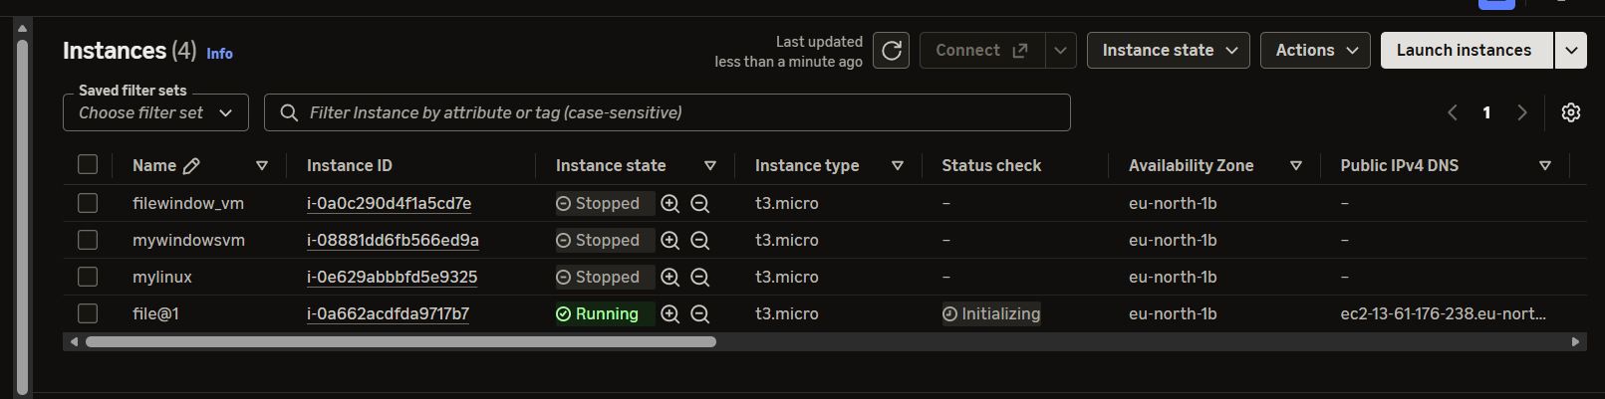

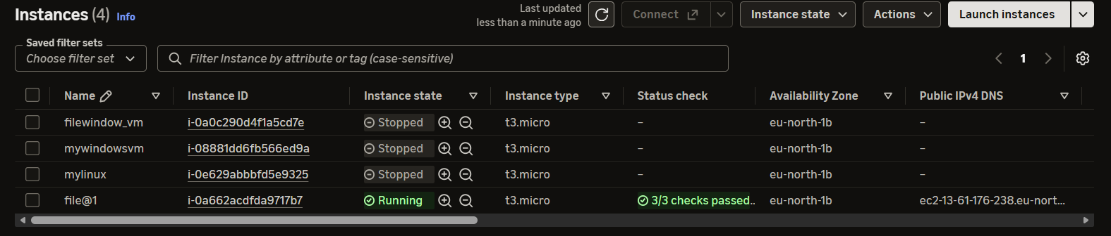
Step 12 :Selecting the Running Instance
Steps:
- Open the Instances page.
- Find your created instance.
- Select the checkbox next to it.
- Check the instance state.
- Click Connect.

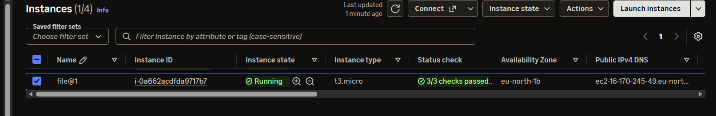
Step 13:Instance Connection Page
Steps:
- Select the running instance.
- Click Connect.
- Open the EC2 Instance Connect option if available.
- Review the connection details.
- Click Connect.

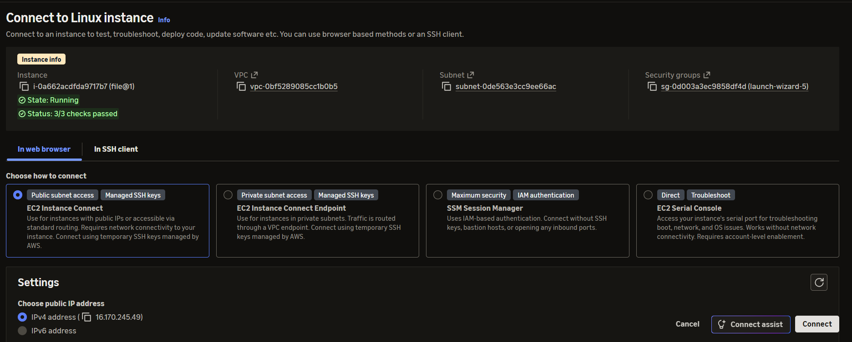
Step 14: EC2 Terminal Access
- Open the connection terminal.
- Wait for the Linux command prompt.
- Enter a basic command such as:
whoami
- Press Enter.
- You can also enter:
pwd
Result: The terminal displays the current user and working directory of the EC2 machine.

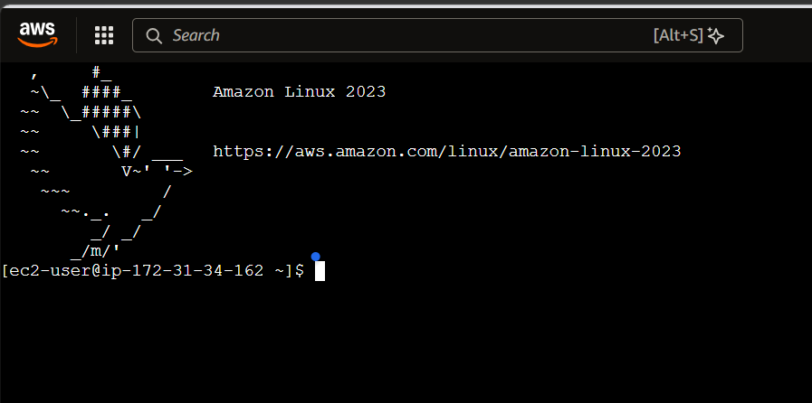
Part C – S3
STEP1 : Searching for Amazon S3
Steps:
- Return to the AWS Management Console.
- Click the search bar.
- Type S3.
- Select S3 – Scalable Storage in the Cloud.
- Wait for the S3 dashboard to open.
Result: Amazon S3 is opened successfully.
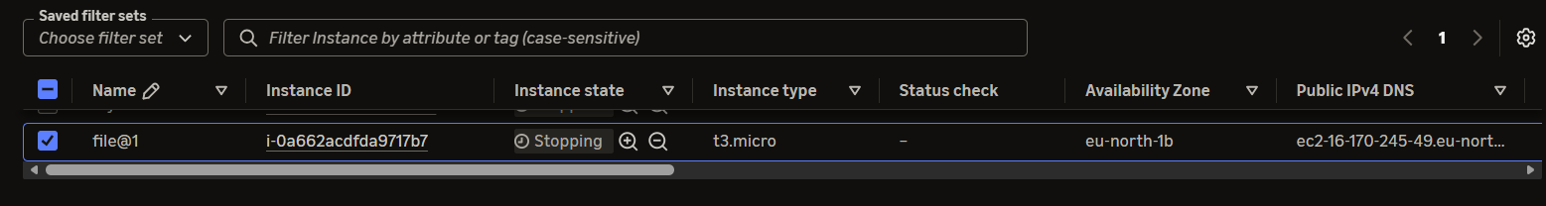

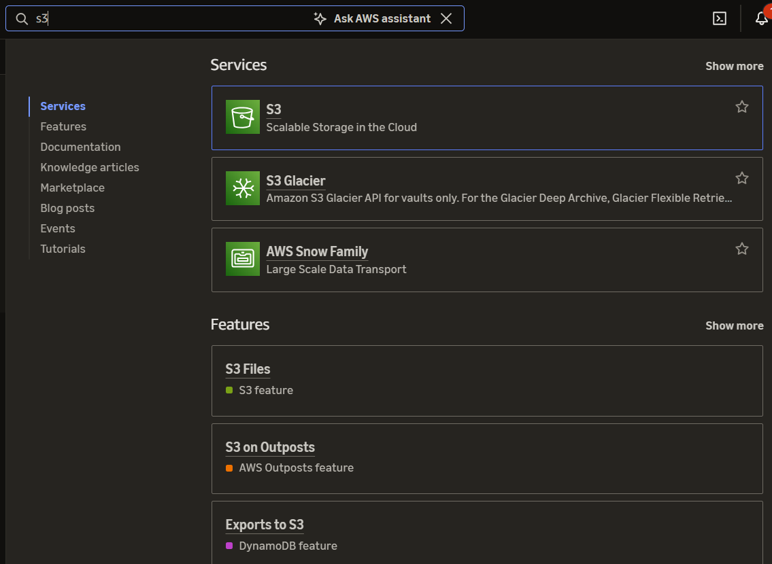

Step 2: S3 Dashboard
Steps:
- Open the S3 service.
- Observe the Buckets section.
- Check the existing buckets.
- Click Create bucket.
Result: The S3 bucket creation page is displayed

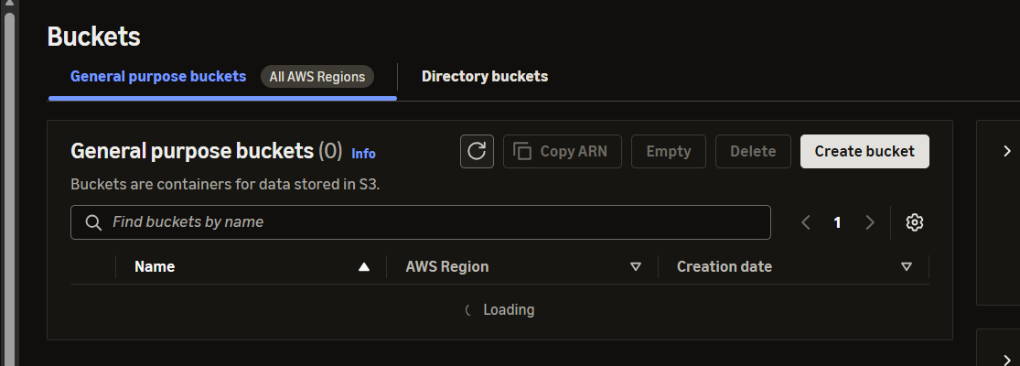
Step 3 : Create Bucket Configuration
teps:
- Click Create bucket.
- Select the required AWS Region.
- Enter a globally unique bucket name.
- Keep the recommended Object Ownership settings.
- Keep Block all public access enabled.
- Review the remaining settings.
- Click Create bucket at the bottom

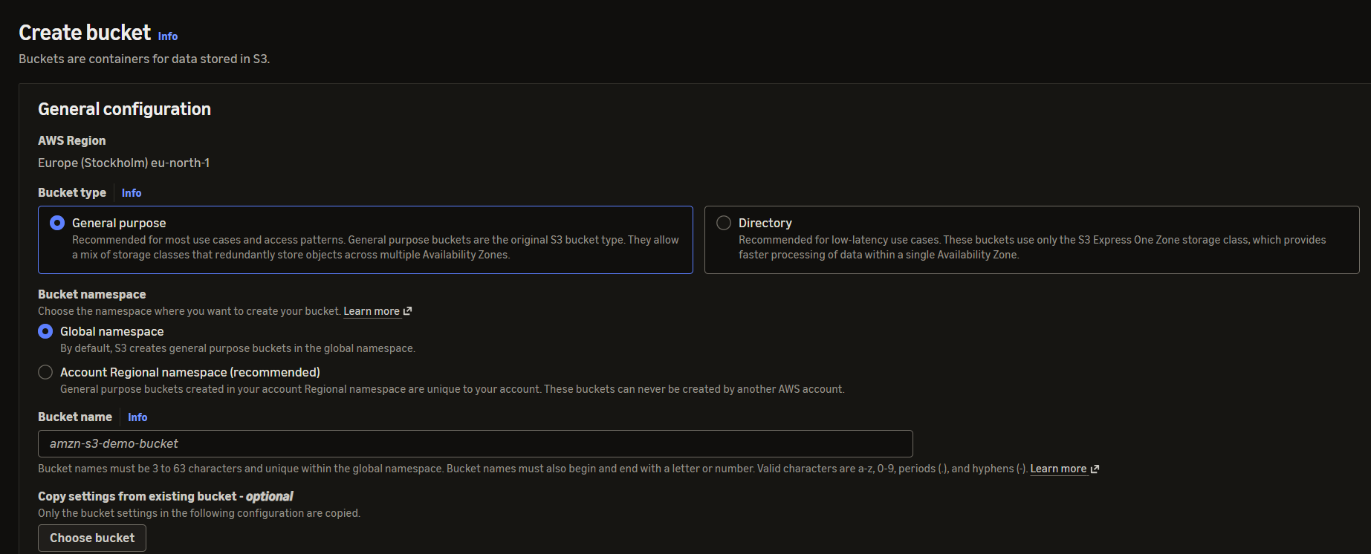
Step 4: Reviewing Bucket Settings
Steps:
- Review the public access settings.
- Keep public access blocked for this experiment.
- Review bucket versioning and encryption settings.
- Use the default recommended settings unless your lab instructions require changes.
- Confirm the bucket configuration.
- Create the bucket.

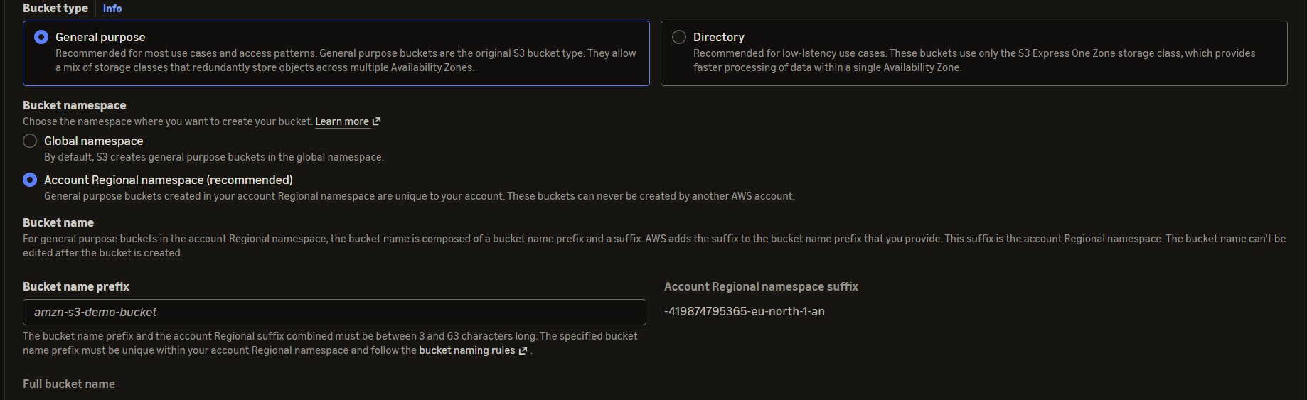
Step 5: Opening the Created Bucket
Steps:
- Open the Amazon S3 dashboard.
- Click Buckets.
- Select the newly created bucket.
- Open the Objects tab.
- Click Upload.

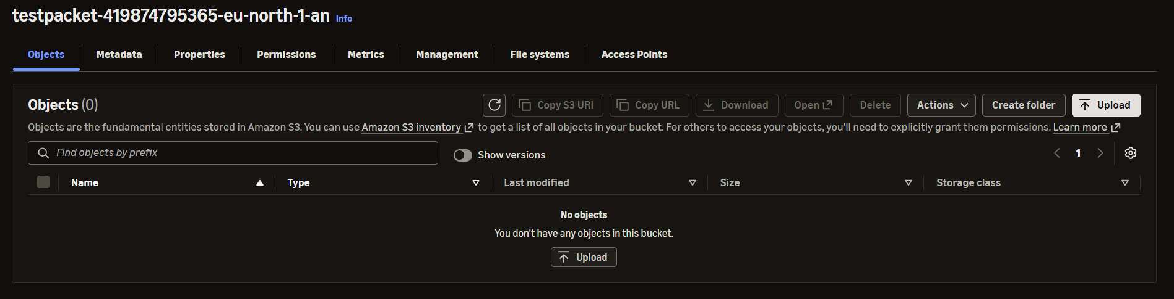
Step 6: Upload Page
Steps:
- Click Add files.
- Select the required file from your computer.
- Alternatively, use Add folder if you want to upload a folder.
- Verify the selected file name.
- Check the file details.
- Click Upload.

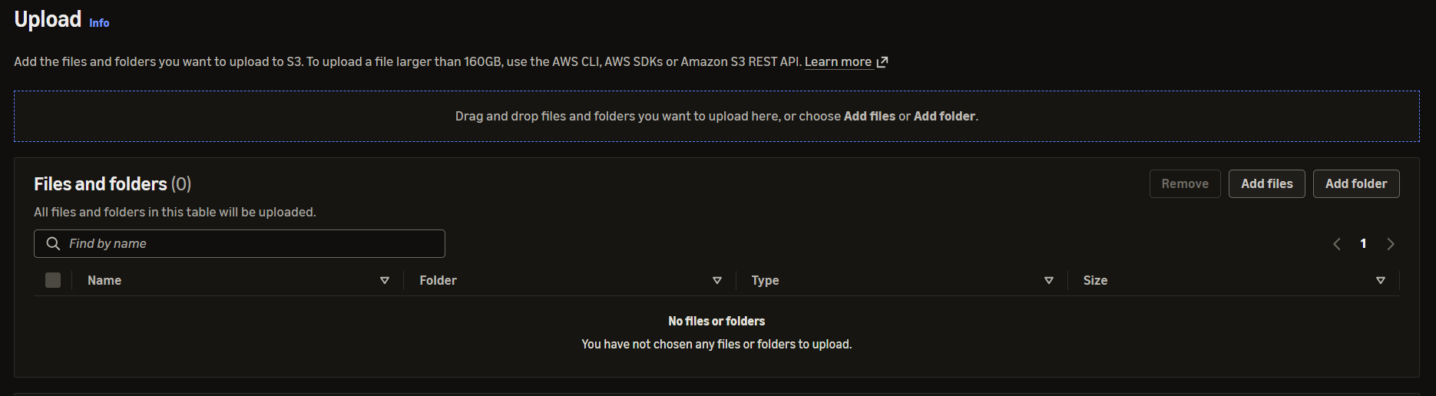
Step 7:Selected File Details
Steps:
- Verify the selected file.
- Check the file name.
- Check the file size.
- Make sure the correct file is selected.
- Click Upload to start uploading.
Result: The selected file is uploaded to the S3 bucket.

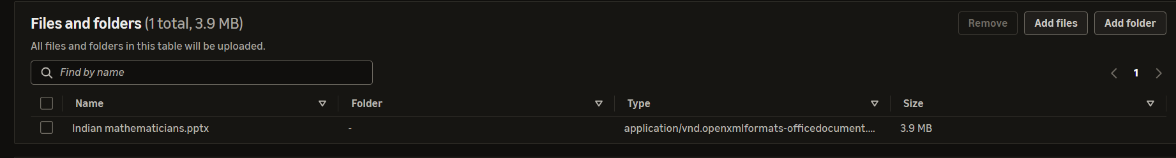
Step 8: Upload Status
Steps:
- Wait until the upload process finishes.
- Check the upload status.
- Verify the success message.
- Check that there are no upload errors.
- Click Close.
Result: The file is successfully uploaded to Amazon S3.

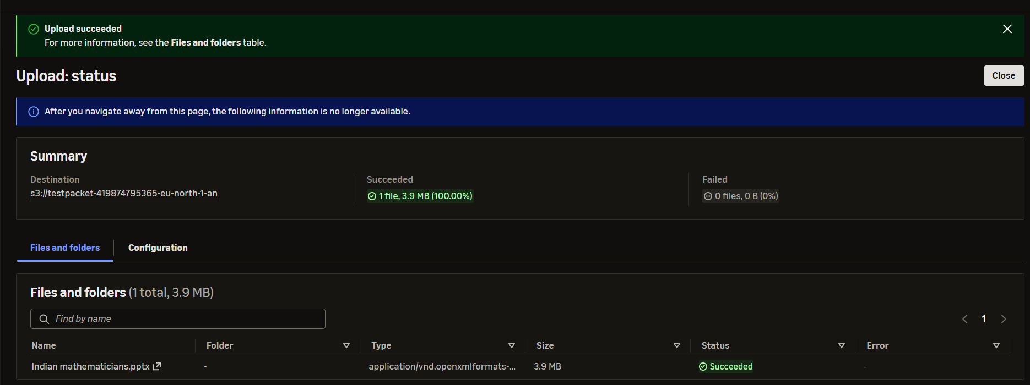
Step 9 : Verifying Uploaded File
Steps:
- Return to the bucket's Objects page.
- Refresh the page if necessary.
- Check the uploaded file name.
- Verify the file type and size.
- Confirm that the object is visible in the list.



